# **Java Basics**

# **Operators**

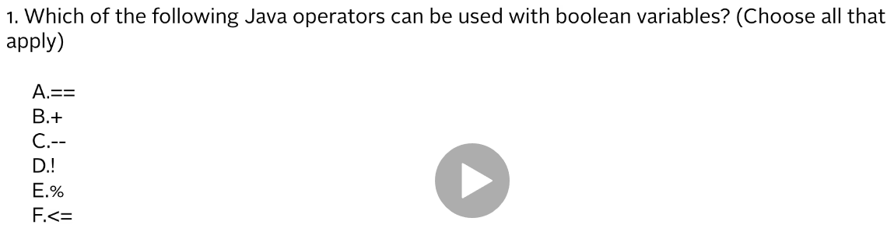

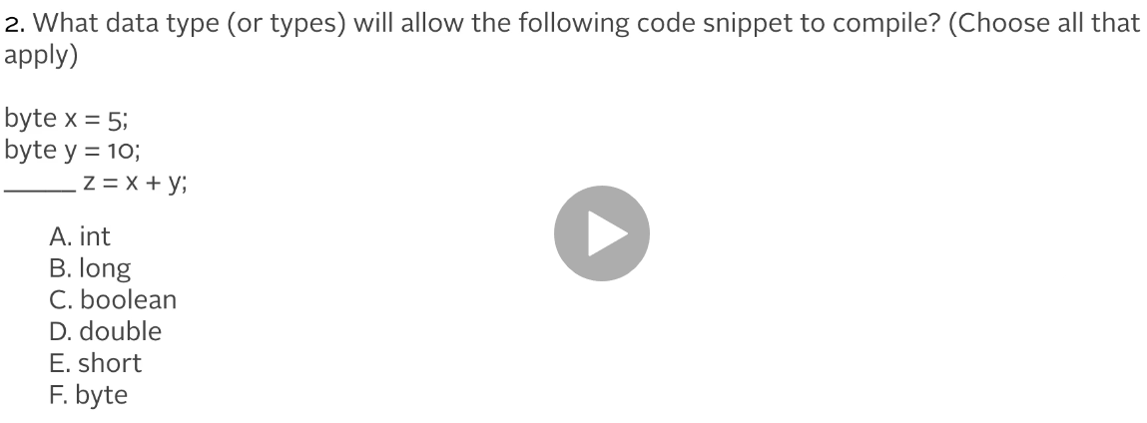

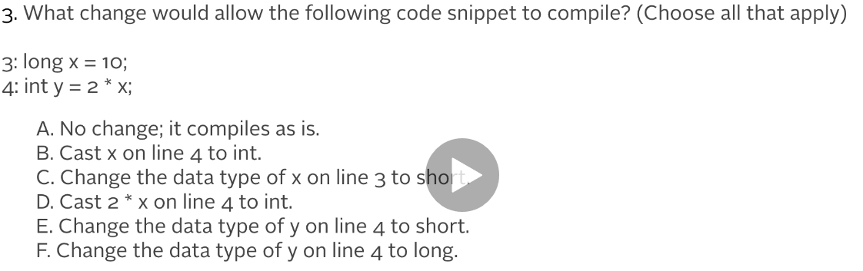

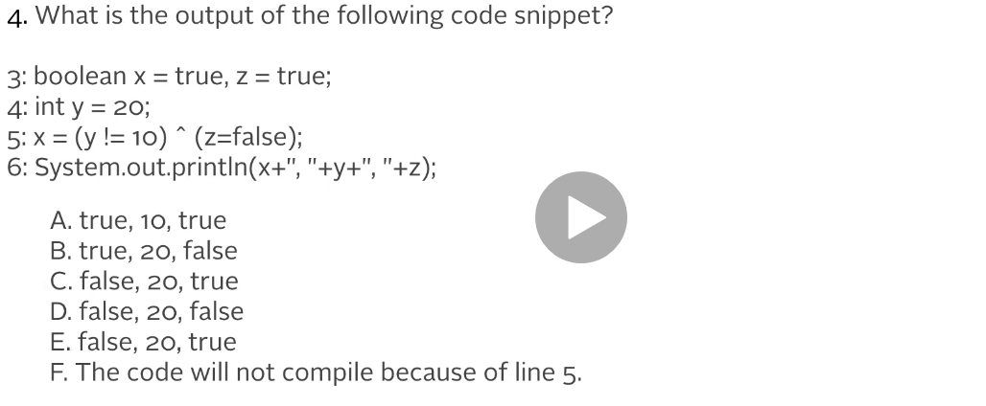

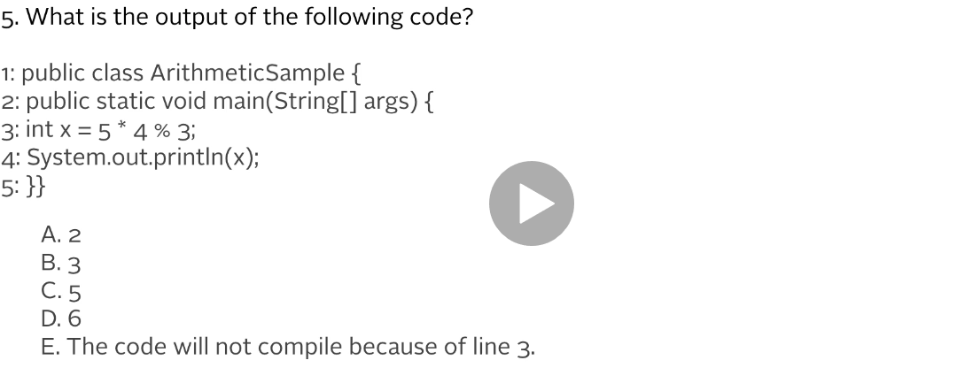

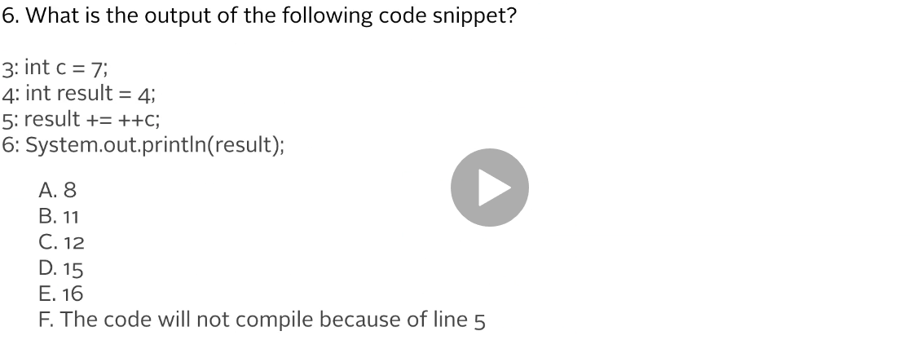

# Answers:

## **Java Basics**:

## **Operators**:

1. A, D
2. A, B, D
3. B, D, F
4. B
5. A
6. C